**University Examination System -Database Documentation**

Database name: university_examination_system

Creating tables:

Table : Department

CREATE TABLE Department(

department_id INT not null primary key,

name varchar(250),

hod_id int

);

Creating a Department Table and the columns are department_id data type Int (Primary key), name data type varchar, hod_id data type Int.



Table : Faculty

CREATE TABLE Faculty(

faculty_id INT not null primary key,

name varchar (250),

department_id INT,

foreign key (department_id) references Department(department_id) on delete cascade

);

Creating a Faculty Table and the columns are faculty_id data type Int (Primary key), name data type varchar, department_id data type Int(Foreign key).

Table : Student

CREATE TABLE Student(

student_id INT not null primary key,

name varchar(250),

enrollment_number int,

department_id INT,

foreign key (department_id) references Department(department_id) on delete cascade

);

Creating a Student Table and the columns are student_id data type Int (Primary key), name data type varchar, enrolment_number data type Int department_id data type Int(Foreign key).



Table : Course

CREATE TABLE Course(

course_id INT not null primary key,

name varchar(250),

course_code varchar(50),

department_id INT,

faculty_id INT,

foreign key (department_id) references Department(department_id) on delete cascade,

foreign key (faculty_id) references Faculty(faculty_id) on delete cascade

);

Creating a Course Table and the columns are course_id data type Int (Primary key), name data type varchar, course_code data type varchar department_id data type Int(Foreign key), faculty_id data type Int(Foreign key). As we can see here that two foreign keys are created which is called Junction table(Mant to many relationship) .

Table : Exam

CREATE TABLE Exam(

exam_id INT not null primary key,

name varchar(250),

exam_date date,

duration time,

total_marks INT,

course_id INT,

foreign key (course_id) references Course(course_id) on delete cascade

);



Creating a Exam Table and the columns are exam_id data type Int (Primary key), name data type varchar, exam_date data type date, duration data type time, total_marks data type Int, course_id data type Int (Foreign key).



Table : Student_exam_result

CREATE TABLE Student_exam_result(

result_id INT not null primary key,

student_id INT,

exam_id INT,

marks_obtained INT,

grade varchar(250),

foreign key (student_id) references Student(student_id) on delete cascade,

foreign key (exam_id) references Exam(exam_id) on delete cascade

);

Creating a Student_exam_result Table and the columns are result_id data type Int (Primary key), student_id data type Int(Foreign key), exam_id data type Int(Foreign key), marks_obtained data type Int, grade data type varchar. As we can see here that two foreign keys are created which is called Junction table(Mant to many relationship) .



Inserting data into tables:

INSERT INTO Department (department_id, name, hod_id) VALUES

(1, 'Computer Science', NULL),

(2, 'Electronics', NULL),

(3, 'Mechanical Engineering', NULL);

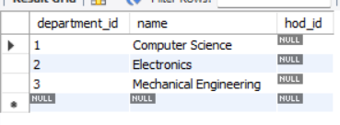



INSERT INTO Faculty (faculty_id, name, department_id) VALUES

(101, 'Dr. A. Verma', 1),

(102, 'Prof. B. Sharma', 2),

(103, 'Dr. C. Khan', 3);

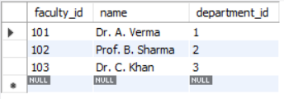

INSERT INTO Student (student_id, name, enrollment_number, department_id) VALUES

(1001, 'Rahul Singh', 202301, 1),

(1002, 'Neha Mehta', 202302, 1),

(1003, 'Amit Rao', 202303, 2),

(1004, 'Priya Das', 202304, 3);

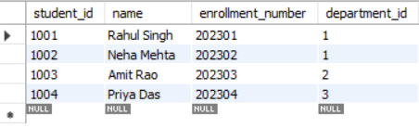



INSERT INTO Course (course_id, name, course_code, department_id, faculty_id) VALUES

(501, 'Database Systems', 'CS301', 1, 101),

(502, 'Digital Circuits', 'EC202', 2, 102),

(503, 'Thermodynamics', 'ME101', 3, 103);

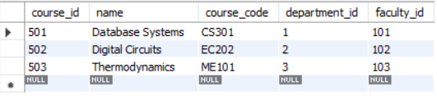



INSERT INTO Exam (exam_id, name, exam_date, duration, total_marks, course_id) VALUES

(201, 'Midterm Exam - DB', '2025-05-01', '02:00:00', 50, 501),

(202, 'Final Exam - DB', '2025-06-10', '03:00:00', 100, 501),

(203, 'Midterm - Circuits', '2025-05-02', '02:00:00', 50, 502);

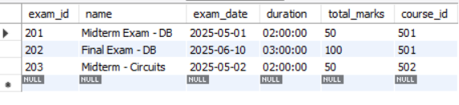

INSERT INTO Student_exam_result (result_id, student_id, exam_id, marks_obtained, grade) VALUES

(301, 1001, 201, 45, 'A'),

(302, 1002, 201, 38, 'B'),

(303, 1003, 203, 42, 'A'),

(304, 1001, 202, 88, 'A+'),

(305, 1002, 202, 76, 'B+');

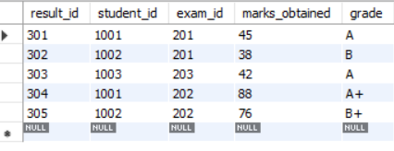



**ER Diagram:**

